**Leader Overview**

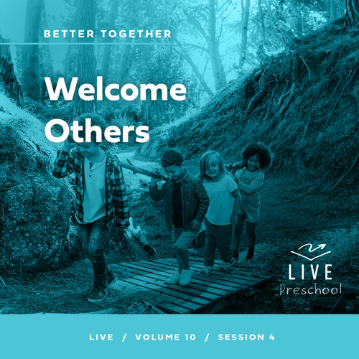

**Volume Overview**

**Better Together**

*The Christian life is never lived alone. When we become a Christian, we’re adopted into God’s family. We’re welcomed into a community. We’re meant to live and grow in faith together. But that takes humility and intentionality. We grow together as we pray and study Scripture together. We bear responsibility for one another by our encouragement and our honoring of those in authority. God is growing us together as one body, one family.*

**Session Overview**

**Welcome Others**

*In this* **Live** *session, preschoolers will discover that they can help new Christians fit in when they come to church so that they can grow in faith. Kids will explore the events after Paul’s miraculous conversion when Barnabas helped convince other believers to trust Paul.*

**Bible Lesson**

Barnabas Stands Up for Paul

[Acts 9:19–30](https://ref.ly/logosref/Bible.Ac9.19-30)

**Faith Fact**

We can help new Christians.

**Faith Verse**

[Ephesians 4:3](https://ref.ly/logosref/Bible.Eph4.3) (NLT)

Make every effort to keep yourselves united in the Spirit, biding yourselves together with peace.

**Preparing for the Session**

**Leader Preparation Time: 20–25 Minutes**

|  |
| --- |
| ***You Will Need***  ***Preservice Activities***  *• Toys*  *• Fudge-striped cookies, two per kid*  *• Large marshmallows, one per kid*  *• Small paper plates*  *• Microwave*  ***Large Group***  *• Bible*  *• Worship songs (Song suggestions: “Alive with You” Lyric Video by Gateway Kids Worship; “I Need You” Lyric Video by Gateway Kids Worship; “Good to Me” Lyric Video by Elevation Church Kids*  *• For groups not using a phone or tablet only, add:*  *• Projector or TV*  *• Laptop*  *•* ***Countdown60 Video****–60 seconds*  *•* ***Faith Fact Sound*** *video (bell ringing)*  *•* ***Faith Fact Slide***  *•* ***Faith Verse Slide***  *•* ***Faith Verse Video***  *•* ***Bible Lesson Video A***  *•* ***Bible Lesson Video B***  ***Small Group***  *• Building blocks*  *•* ***Small Group Activity Page****, one per kid*  *• Pencils or pens, one per kid*  *• Crayons or markers*  *• Small buckets, three*  *• Balls*  *• Laundry basket*  *•* ***Countdown60 Video*** *– 60 seconds*  *• Play dough*  *To access session content and videos from a computer, visit:* [***BibleEngagementProject.com/downloads***](https://bibleengagementproject.com/downloads) |
| **Getting Ready**  **Preservice Activities**  • Set out toys and snacks.  **Large Group**  • Download videos and slides if needed.  • Select worship song(s) and have them ready to play.  **Small Group**  • Print copies of the **Small Group Activity Page**, one per kid.  • Place the three empty buckets around the room.  • Place the balls in the laundry basket.  ***First time leading* Live *for Preschool? Check out* *the*** [**Facilitator Guide**](https://0b769b0ed3569ef9d18b-f88d8272f61086866d50d048b43ef630.ssl.cf2.rackcdn.com/sites/biblengagementproject/Listen_Facilitator_Guide.pdf)**.** |

**Preservice Activities**

*See what’s needed at the beginning of the session.*

**Bible Story Warm-Up**

Have you ever been somewhere new before? *(Group response)* Maybe you moved to a new house or new school. Sometimes being in a new place can be scary.

• *Tell a personal story of moving somewhere new when you were a kid if you have one.*

Sometimes going to a new place can be exciting. For example, if your family goes to a new park, you might be super excited because they might have new things to play on.

Have you ever moved to a new school or house?

How did you feel when you have to go somewhere new?

What can we do when someone is new at school or here at church to help them feel welcome?

In our Bible story, we’ll learn about a time when a man was somewhere he had never been before. He was doing something new, and people weren’t sure he would be nice to them. Then, someone who loved Jesus decided to help the man and be his friend. Today will be amazing, and I can’t wait to learn more about God’s Word with you.

**Snack**

**Inside S’mores**

There are a lot of things in life that we need help with, and today’s snack is one of those things. Today, we are making indoor s’mores for snack.

• *Hand out a plate with ingredients to each kid.*

• *Optional: Label the plates with kids’ names if you are heating more than one plate at a time.*

Everyone should have two cookies and a large marshmallow. First, you need to put the large marshmallow on one of the cookies with the chocolate side up. Then, you’ll carry your plate to the microwave.

• *Help kids complete these steps.*

Now, let’s work together for the next step. I’ll need you to hold the second cookie while your snack is in the microwave. Don’t sneak any bites! You’ll need to help watch to tell me when your treat is warm enough. You can tell because the marshmallow will get bigger.

• *Place kids’ plates in the microwave.*

• *Turn on the microwave and let kids see when their marshmallow starts to expand.*

• *Stop the microwave and help kids put the other cookie on top, chocolate side touching the marshmallow.*

• *Let kids eat the snack.*

You did a great job building your snack. Learning new things is sometimes hard to do by yourself. Making this snack might have been hard if I didn’t help you. The same is true when we follow Jesus. That’s why God wants us to help each other be more like Jesus.

**Free Play**

*Any extra time can be spent playing with toys.*

**Transition**

*A few minutes before service begins have kids make their way to the large group area and sit in their designated areas.*

**Large Group**

**25 Minutes**

*See what’s needed at the beginning of the session.*

**Introduction**

Hello, kids! I’m so excited to see each of your smiling faces here today! On the count of three, let’s make our biggest smile to each other. 1, 2, 3. *(Group response)* Wow! Did you know how talented you are at smiling? Because you are top-notch smilers, I’ll need to practice to keep up with you. Today, we’ll do some more smiling as we learn from God’s Word together. *(Hold up the Bible.)*

Today, we’ll learn about Paul. When he decided to follow Jesus, he needed Jesus’ forgiveness. He also needed a new friend to help him. That friend was named Barnabas. God wants us to be like Barnabas in today’s Bible story. Let’s find out why.

**Faith Fact**

Paul needed someone to help him because he was a new Christian. That’s something every one of us can do. Today’s Faith Fact is **We can help new Christians.**

• *Show the* ***Faith Fact Slide.***

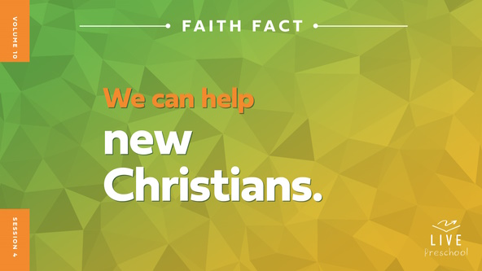

Let’s say our Faith Fact together. The first time we say it, let’s point to ourself when we say the word *we*. **We can help new Christians.** Awesome! This time, let’s shout it! **We can help new Christians**.

**Bible Time**

We need to know how to help new Christians. Where do you think we learn the most important truths about that? *(Hold up the Bible.)* Yes! In the Bible, which is God’s Word. We’ve got some special friends to help us do that. Let’s check in with Lizzy and Grandpa.

• *Play* ***Bible Lesson Video A****.*

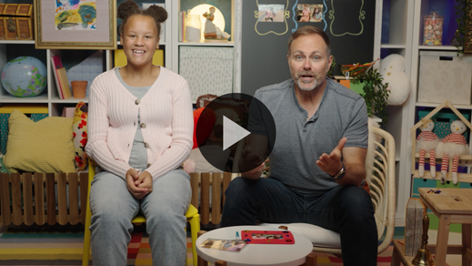

What a great question! I’ll need time to think about that one. Let’s worship God first, and then I’ll ask you what you think will happen next in our Bible story.

**Worship**

One way we show God how much we love Him is through our praise and worship. God loves to hear us worship Him. Let’s focus our heart and mind on how amazing God is. He deserves our praise.

**Praise**

Who wants to thank God for giving us friends? Give a high five to the friend next to you. *(Group response)*

Are you glad God made you and me? Wave your hands up high. *(Group response)*

Who wants to thank God for giving us the Bible, His Word? Jump as high as you can. *(Group response)*

**Sing**

Let’s warm up our singing voices. *(La-la-la-la)* What a beautiful sound! We get to use our voices to worship God.

• *Lead the kids in singing one or two songs. See song suggestions at the beginning of the session.*

**Prayer**

Let’s all bow our heads and pray.

|  |
| --- |
| *Dear God, You give us so many good things in life, including friends to help us. We thank You for Your love. We thank You that You promise to always be with us. Amen.* |

**Bible Time cont’d**

I think it’s time for Grandpa and Lizzy to come back! Let’s each put on our thinking cap *(demonstrate)* and decide what we think will happen next in the Bible story. Did Barnabas help Paul? *(Point to the thumbs up graphic.)* Or did Barnabas leave Paul without helping him? *(Point to the thumbs down graphic.)*

If you think Barnabas helped Paul, show me a thumbs up. If you think Barnabas didn’t help Paul, give me a thumbs down. Ready? Choose your answer.

• *Pause while kids respond.*

Let’s find out if you’re right! We’ll check back in with Lizzy and Grandpa.

• *Play* ***Bible Lesson Video B.***

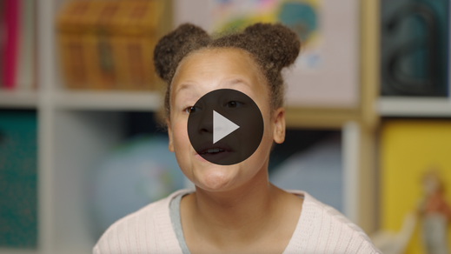

Barnabas was a good friend to Paul. How can we tell if someone is a good friend? *(Allow responses.)* A good friend helps us when we need it, and that’s what Barnabas did for Paul.

**Response Time**

*Play a worship song quietly.*

Let’s respond to what we’ve learned today. We want to be good friends to others, especially to people who are new Christians or are new to our group. When new friends need help, God can speak to us and show us how we can help them. When God speaks to us, we won’t hear His voice, but we will know with our mind and heart that He wants us to help a new friend. Let’s pray and ask God to help us be good friends to those around us, especially when they are new.

• *Have the kids repeat phrases of the prayer after you.*

|  |
| --- |
| *Dear God, thank You for friends. I want to be a good friend to others. Help me to see people who need Your love and my help. Amen.* |

**Faith Verse**

God teaches us such important truths in the Bible. Let’s practice the Faith Verse we’ve been learning and do the actions together.

[Ephesians 4:3](https://ref.ly/logosref/Bible.Eph4.3) (NLT)

Make every effort to keep yourselves united in the Spirit, binding yourselves together with peace.

• *Play* ***Faith Verse Video****.*

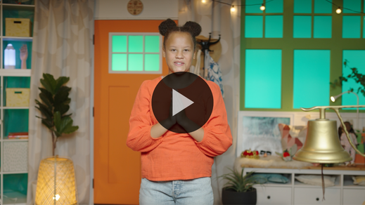

**Ephesians** *(hands at waist, spread apart, palms up and out)*

**4:** *(hands together like a clap)*

**3** *(hands opened to “book”)*

**Make every effort** *(sweep hands out and to the sides)*

**to keep yourselves united** *(bring hands together in a clap)*

**in the Spirit,** *(clap twice with the syllables of “Spirit”)*

**binding yourselves together** *(wrap arms around like a hug)*

**with peace.** *(bow head and whisper)*

**Closing**

I’ve had so much fun with you today. Have you learned more about God and His Word? *(Group response)* Let’s see if we’ve done everything. Did we worship God by singing and praying? *(Group response)* What about our Faith Verse? *(Group response)* Oh yes, I remember us practicing that because you all said it so well! We connected with Lizzy and Grandpa for a Bible story. What else is there?

• *Play the* ***Faith Fact Sound*** *video (bell ringing).*

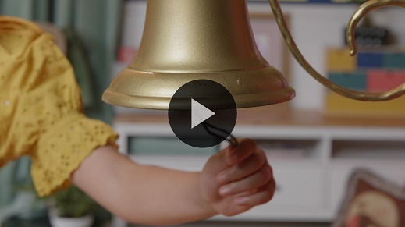

Hey! That sound means we get to say our Faith Fact one last time. **We can help new Christians**.

• *Show the* ***Faith Fact Slide.***



That was so much fun I think we should say it one more time. Are you ready? **We can help new Christians**. I don’t know that I heard you that time. Can you say it any louder? **We can help new Christians**. I heard it that time. Great job, everyone!

**Dismissal to Small Groups**

Now, it’s time to put our Faith Fact into action as you move into small groups. Be sure to watch for how you can help your friends!

• *Dismiss the kids by groups.*

|  |
| --- |
| ***Leader Tip:*** *This can be done by assigning color teams or by age groups. Note that some young preschoolers may not know their age. Using a colored sticker, jersey, or wristband will help separate the kids and help identify their small groups.* |

**Small Group**

**25 Minutes**

*See supplies and prep instructions at beginning of session or in each activity below.*

|  |
| --- |
| ***Leader Tip:*** *Small groups can alternate to each circle, or all groups can do each activity at the same time. If you choose to alternate, you will need at least one leader per circle.* |

**Circle 1**

**Group Connection**

**New Building**

|  |
| --- |
| ***You Will Need***  *• Building blocks*  *No prep is needed for this activity.* |

If you’re ready to play a game, let me hear you say, “Oh, yeah!” (*Group response)* This will be awesome! We’ve learned that we should help others grow in their love and relationship with Jesus. When we help others grow, it reminds me of building something new.

As you can see, we have a pile of blocks here in the middle of our circle. Let’s see if we can make a tower. We’ll take turns adding a block to our tower to see how tall we can make it. When you add a block, I want you to tell everyone your favorite way to spend time with God. It could be praying, worshipping, talking to Him while you’re playing outside, or so many other things.

If our tower falls, we’ll all say our Faith Fact together. **We can help new Christians**. Then, we’ll start building again. Let’s see how tall we can build our tower.

• *Build the tower as kids share.*

• *Optional: Ask new questions to help kids get to know each other as the activity continues.*

I can tell that you love spending time with God. Before we move on, let’s say our Faith Fact together one more time. This time, let’s say it as loud as we can. Ready? **We can help new Christians.**

**Circle 2**

**Activity Page Time**

**Helping Hands**

|  |
| --- |
| ***You Will Need***  *•* ***Small Group Activity Page****, one per kid*  *• Pencils or pens, one per kid*  *• Crayons or markers*  ***Getting Ready***  *• Print copies of the* ***Small Group Activity Page****, one per kid.* |

Today we’ve talked about helping others grow closer to Jesus. When somebody is a new Christian, they need friends. They may not know exactly how to grow in their faith, so they need help. God has placed us in their life so that we can help them know more about Him. Wait! That’s exactly what our Faith Fact says. Say it with me. **We can help new Christians**. That’s right! **We can help new Christians**.

• *Hand out a copy of the* ***Small Group Activity Page****, a pencil, and crayons to each kid.*

On your Activity Page, you can see words that talk about our Faith Fact. Cover them with your hand and trace around your hand. Then next to your hand outline, draw one way that you can help someone know more about Jesus. Maybe you’ll draw a picture of a book as a reminder to tell them about the Bible. You could draw a microphone as a reminder to share worship songs with them. There are so many ways that we can help others. I can’t wait to see your pictures.

• *While kids are working, be ready to offer suggestions and ideas.*

• *During the activity, interrupt and practice the Faith Fact:* **We can help new Christians.**

• *Play the* ***Faith Fact Sound*** *video. Review the Faith Fact even if you can’t play the sound.*



Wow, these pictures all look amazing! I’m excited to see how each of you will help others grow to be more like Jesus. Before we move on, let’s say our Faith Fact again one more time. Ready? **We can help new Christians**.

**Circle 3**

**Feet-to-Floor Game Time**

**Better Together**

|  |
| --- |
| ***You Will Need***  *• Small buckets, three*  *• Balls*  *• Laundry basket*  *•* ***Countdown60 Video*** *– 60 seconds*  ***Getting Ready***  *• Place the three empty buckets around the room.*  *• Place the balls in the laundry basket.* |

Does anyone want to play a super fun game? *(Group response)* Great! Today’s game will require everyone to work together as one big team. That reminds me of our Faith Verse. Can you say it after me?

• *Lead kids in the Faith Verse with actions.*

[Ephesians 4:3](https://ref.ly/logosref/Bible.Eph4.3) (NLT)

Make every effort to keep yourselves united in the Spirit, binding yourselves together with peace.

Great job! This game is simple. There are three empty buckets around the room. I have this basket filled with balls. When the game starts, I’ll scatter the balls around the room. Every one of you will have a partner. One will pick up balls, and one will carry the balls one at a time to the empty buckets. The goal is to work together to pick up all the balls in the room before time runs out. You’ll only have one minute. Do you think you can beat the clock? *(Group response)* Let’s try!

• *Start the* ***Countdown60 Video****-60 seconds and give kids time to play.*

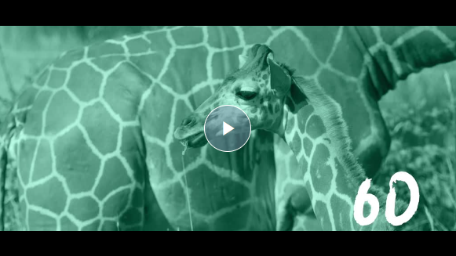

• *Before starting another round, have the kids repeat the Faith Verse.*

That was amazing! God wants His children, that’s you and me, to be united. *United* means that we work together. When we work together, we can do so much more for God.

**Circle 4**

**Hands-On Learning**

**Play Dough Fun**

|  |
| --- |
| ***You Will Need***  *• Play dough*  *No prep needed for this activity.* |

In our Bible story, we learned about a time soon after Paul met Jesus. He was new to God’s family and needed help learning how to follow Jesus. Barnabas was a great friend and helped Paul to grow. Our Faith Fact today has taught us that we can help others. Who can tell me what our Faith Fact is? *(Allow responses.)* Great job! Now, let’s say it all together. **We can help new Christians**. That’s so true. We can and should help new Christians grow in their walk with Jesus.

• *Hand out some play dough to each kid.*

Use your play dough to make Paul and Barnabas. In our story, Barnabas helped Paul learn more about Jesus. When you’re done, tell us who you can help to learn more about Jesus.

**Dismissal**

• *Play the* ***Faith Fact Sound*** *video (bell ringing).*



• *Show the* ***Faith Fact Slide.***



Wow! Today has been one of my favorite days! I have loved getting to learn more about God’s Word with you. I hope that each of you will share God’s love with someone important to you. Before we leave today, let’s say our Faith Fact one more time. Ready? **We can help new Christians**. Great job! See you next time!

• *Send home the* ***Small Group******Activity Page*** *with each kid.*

• *Remind parents that there are* ***Family Devotions*** *available on the app to do with their kid.*

• *Tell everyone the date and time for the next session.*